Clinical Image
[Full manuscript title]
Citation: Schuingel DCO. The Use of Melaleuca alternifolia for the Treatment of Labial Herpes: A Clinical Case Study. Brazilian Journal of Aromatherapy and Essential Oil. 2024;1: bjhae15.
doi: https://doi.org/10.62435/2965-7253.bjhae.2024.bjhae15
Received: 15 May 2024
Accepted: 2 June 2024
Published: 10 June 2024


Copyright: This work is licensed under a Creative Commons Attribution 4.0 International License (CC BY 4.0).
[Author One]1; [Author Two]2; [Author Three]1,*

¹ [Institution/Department], [City], [State/Province], [Country]..
² [Institution/Department], [City], [State/Province], [Country].

* Correspondence: email@gmail.com.
Keywords: [Keyword 1]. [Keyword 2]. [Keyword 3]. [Keyword 4]..
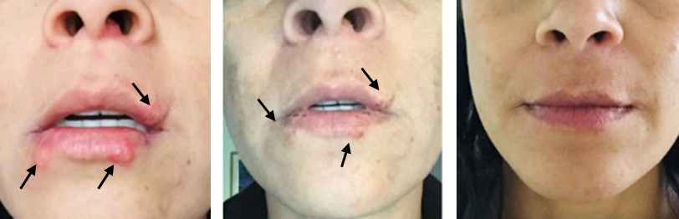
B

Figure 1: A. Initial presentation of herpes lesions before treatment. B. Clinical improvement after 3 days of treatment. C. Near complete resolution of lesions after 7 days of treatment with BLEND of essential oils.

Herpes simplex virus (HSV) infections are common and often lead to recurrent episodes of painful sores. Traditional treatments include antiviral medications, but complementary and alternative therapies are increasingly being explored. This report documents the use of Melaleuca alternifolia (tea tree oil) essential oil in treating an established herpes infection [1, 2]. An adult woman patient presented with an active labial herpes infection (Figure 1A). The therapeutic regimen included use of essential oils of Melaleuca alternifolia for its antiviral properties, and Lavandula angustifolia to provide emotional support. Both essential oils were diluted to a 5% concentration in a carrier oil (coconut oil) and applied topically using a roll-on applicator. The treatment was administered locally over a period of 7 days.
The essential oils were prepared by diluting 5% of each in coconut oil. The blend was applied topically three times a day for 7 days. The patient’s progress was documented through photographic evidence taken on the first day before treatment, after 3 days of treatment, and after 7 days. The initial image (Figure 1A) shows multiple erythematous vesicular lesions characteristic of a herpes outbreak. After three days of application (Figure 1B), a significant reduction in erythema and vesiculation was observed. The lesions were noticeably less inflamed, and the patient reported reduced pain and discomfort. By the end of the treatment period (Figure 1C), the lesions had almost completely resolved. The skin appeared healed with minimal residual erythema and no new vesicular formations. The patient reported an overall improvement in both physical symptoms and emotional well-being.
Melaleuca alternifolia (tea tree oil) is known for its antimicrobial and antiviral properties, making it a suitable candidate for treating herpes infections [3]. Lavandula angustifolia (lavender oil) is widely used for its calming and stress-relieving effects, which can be beneficial in managing the psychological impact of herpes outbreaks. This case demonstrates the potential effectiveness of combining these essential oils in a topical application for treating herpes simplex lesions. In summary, the combination of Melaleuca alternifolia and Lavandula angustifolia essential oils in a 5% dilution with coconut oil proved to be effective in reducing the severity and duration of a herpes outbreak. Further research and larger studies are warranted to establish these findings and explore the full potential of essential oils in treating viral infections.
Funding: None.
Research Ethics Committee Approval: The study, conducted in accordance with the Declaration of Helsinki, followed ethical guidelines, ensuring adherence to principles, and obtaining the patient's informed consent.
Acknowledgments: None.
Conflicts of Interest: None.
Supplementary Materials: None.

References
- Ma L, Yao L. Antiviral Effects of Plant-Derived Essential Oils and Their Components: An Updated Review. Molecules. 2020 Jun 5;25(11):2627. doi: 10.3390/molecules25112627. PMID: 32516954; PMCID: PMC7321257.
- Carson CF, Ashton L, Dry L, Smith DW, Riley TV. Melaleuca alternifolia (tea tree) oil gel (6%) for the treatment of recurrent herpes labialis. J Antimicrob Chemother. 2001 Sep;48(3):450-1. doi: 10.1093/jac/48.3.450. PMID: 11533019.
- Asif M, Saleem M, Saadullah M, Yaseen HS, Al Zarzour R. COVID-19 and therapy with essential oils having antiviral, anti-inflammatory, and immunomodulatory properties. Inflammopharmacology. 2020 Oct;28(5):1153-1161. doi: 10.1007/s10787-020-00744-0. Epub 2020 Aug 14. Erratum in: Inflammopharmacology. 2021 Apr;29(2):577. doi: 10.1007/s10787-021-00788-w. PMID: 32803479; PMCID: PMC7427755.

