Original Research
Analysis of the Effects of Aromatherapy in Elderly Patients at Gaffrée and Guinle University Hospital
Citation: Pereira MCP, Souza Jr FG, Santos ALP, Ribeiro HA, Laszlo F, Barragan P, Piacsek P, Sena MER. Analysis of the Effects of Aromatherapy in Elderly Patients at Gaffrée and Guinle University Hospital. Brazilian Journal of Aromatherapy and Essential Oil. 2026;3: bjhae3.

Doi: ttps://doi.org/10.62435/2965-7253.bjhae.2026.3.bjhae3
Received: 05 February 2026
Accepted: 20 February 2026
Published: 10 Mach 2026


Copyright: This work is licensed under a Creative Commons Attribution 4.0 International License (CC BY 4.0).
Michelle Colão de Paula Pereira¹; Fernando Gomes de Souza Jr¹ ; Ana Luisa Pereira dos Santos²; Henry Aguiar Ribeiro²; Fabian Laszlo³, Patricia Barragan³, Patricia Piacsek⁴; Maria Eugênia Ribeiro de Sena⁵

¹ Universidade Federal do Rio de Janeiro – PENT/COPPE/UFRJ, Rio de Janeiro, Brazil.
² Universidade Federal do Estado do Rio de Janeiro- Instituto de Biomedicina, Rio de Janeiro, Brazil.
³ Instituto Aromas da Terra Pesquisa e Educação, Fortaleza, Ceara, Brazil.
⁴ Universidade de São Paulo – USP/Instituto de Geociências, São Paulo, Brazil.
⁵ Universidade Federal do Estado do Rio de Janeiro- Instituto de Biociências, Rio de Janeiro, Brazil.

* Correspondence: maria.sena@unirio.br
Abstract: Clinical aromatherapy for chronic pain using essential oils aims to evaluate the therapeutic effects in elderly participants at the Gaffrée and Guinle University Hospital (HUGG) in Rio de Janeiro who experience chronic pain. Initially, an anamnesis was conducted, followed by an olfactory test with ten essential oils to select three aromas for the preparation of the synergy blend. During the first consultation, the aromatherapist evaluated each participant, identifying their main complaints—both physical and emotional/psychological—and subsequently prepared a personalized synergy blend, which could be administered via inhalation and/or topical application. After two months of using the blend, a follow-up consultation was conducted to assess symptom levels before and after the aromatherapy intervention. The results indicated a positive outcome, as most participants reported significant improvement in their previously noted symptoms. Therefore, it can be concluded that aromatherapy represents an effective and alternative approach to treating the body, addressing both physical and psychological aspects.
Keywords: Clinical aromatherapy; elderly; chronic pain; essential oils

1. Introduction
Clinical aromatherapy is a therapeutic practice that utilizes essential oils extracted from plants to promote physical, mental, and emotional well-being (1). Unlike traditional aromatherapy, the clinical approach is more evidence-based and is often integrated into healthcare settings such as hospitals and clinics.
Although the term "aromatherapy" has only been used since the 20th century to describe the therapeutic use of essential oils, the practice dates back to ancient Egyptian civilization, where various plants were used to prepare infusions and healing ointments. It was not until the 1920s, with the studies of French chemist René-Maurice
Gattefossé on medicinal plants, that aromatherapy began to be regarded as a complementary form of treatment to modern medicine. Today, it is recognized as a complementary and integrative health practice (CIHP).
Essential oils are aromatic compounds resulting from the secondary metabolism of plants and are highly concentrated. They can be extracted from flowers, leaves, roots, and other plant parts (2). Each essential oil possesses unique therapeutic properties, such as anti-inflammatory, antimicrobial, relaxing, or stimulating effects.
In clinical aromatherapy, essential oils are selected and administered based on the patient’s specific needs, considering their health condition, medical history, and other relevant factors. Methods of application may vary according to the patient's preferences or requirements and may include inhalation, topical application, or therapeutic baths.
The benefits of aromatherapy vary but may include relief from symptoms such as pain, anxiety, insomnia, and digestive discomfort (3). It is frequently used as an adjunct to conventional medical treatment, aiding in stress management, postoperative recovery, and improved quality of life in patients with chronic illnesses (4). Additionally, there are various psychological benefits, including enhanced self-esteem, although the extent of this influence remains under debate (5). Thus, aromatherapy emerges as a promising holistic approach to healthcare (6). The growing body of research supporting the efficacy of essential oils opens new opportunities for both the healthcare sector and industry, given that well-being and quality of life can be improved with minimal side effects.
Another factor contributing to the rise of aromatherapy is population aging, driven by increased life expectancy and declining birth rates (7). It is understood that, globally, the age pyramid is gradually inverting—with a narrower base and broader top—indicating a growing elderly population. Given that aromatherapy is a non-invasive therapeutic method with few adverse effects, it becomes a valuable ally in emerging care strategies for older adults. Numerous studies have demonstrated that this type of treatment is well accepted among the elderly, not only due to its anti-inflammatory properties and low incidence of side effects (8), but also because it is viewed more positively, as the geriatric population often favors more natural and less synthetic approaches.
2. Material and Methods
This study was developed through the implementation of an extension project conducted at the Gaffrée and Guinle University Hospital, where aromatherapy sessions were carried out with elderly participants to analyze the therapeutic effects of essential oils, both from physical and psychological perspectives. The research protocol was approved by the Ethics Committee of the Federal University of the State of Rio de Janeiro (UNIRIO), and all participants provided informed consent by signing the Free and Informed Consent Form.
Initially, consultations were conducted by both the project coordinator and collaborating students. During this stage, patients were welcomed into the consultation room for an anamnesis. Each patient’s record included personal data and questions regarding their main physical and psychological complaints, as well as information about regular medications and medical history. This allowed for a comprehensive analysis of potential drug interactions with essential oils and any contraindications related to specific health conditions.
Following the interview, participants were presented with ten different essential oils: Rosemary (Rosmarinus officinalis), Star Anise (Illicium verum), Lemongrass (Cymbopogon flexuosus), Lemon Eucalyptus (Eucalyptus citriodora), Eucalyptus Globulus (Eucalyptus globulus), Peppermint (Mentha piperita), Sweet Orange (Citrus sinensis), True Lavender (Lavandula angustifolia), Lemon (Citrus limonum), and Tea Tree (Melaleuca alternifolia). These oils were grouped into five opposing pairs, and participants were asked to choose one oil from each pair. From the five selected oils, they were then asked to choose three to compose their personalized synergy blend.
A total of 31 patients were randomly divided into four groups (ranging from 5 to 10 individuals), each receiving a different method of synergy application. The first group (G1) used the synergy via inhalation, receiving a small vial containing a blend of sunflower oil (used as a carrier) and low concentrations of the selected essential oils (2–3%). The second group (G2) received the synergy via topical application in the form of a massage cream containing the chosen oils. The third group (G3) combined both methods—topical and inhalation—while the fourth group (G4) served as the control group. Detailed instructions were provided for each application method, and a demonstration was conducted at the end of the consultation.
After a two-month period of consistent use of the synergy, participants were invited for a follow-up consultation, during which a second anamnesis was conducted to assess any perceived changes in their previously reported symptoms.

3. Results

A relatively uniform distribution was observed in the selection of essential oils, with most oils being chosen approximately ten times, showing little variation. Notable exceptions included Eucalyptus Globulus (Eucalyptus globulus) and Tea Tree (Melaleuca alternifolia), which were selected significantly less frequently—only 2 and 5 times, respectively. Conversely, Sweet Orange (Citrus sinensis) emerged as the most frequently chosen oil, appearing in two-thirds of the olfactory preferences.
A chart (Figure 1) was created to illustrate the distribution of olfactory preferences recorded during the anamnesis. However, it is important to note that the final selection was occasionally influenced by safety considerations. Certain oils, despite being initially chosen, were excluded from the synergy formulation due to potential side effects, particularly among high-risk individuals, as identified during the consultation and data collection process.

Figure 1: Chart of olfactory preferences of 30 elderly.

According to the collected data, the three most frequently selected essential oils were Sweet Orange (Citrus sinensis), Star Anise (Illicium verum), and Lavender (Lavandula angustifolia).
When comparing patient reports before and after the use of these oils, a significant reduction in both pain and anxiety levels was observed. Quantitative data (Figure 2) demonstrate a 50% reduction in pain-related complaints and an 80% decrease in reported anxiety. These findings suggest a positive correlation between the application of the aforementioned essential oils and improvements in the evaluated symptoms.
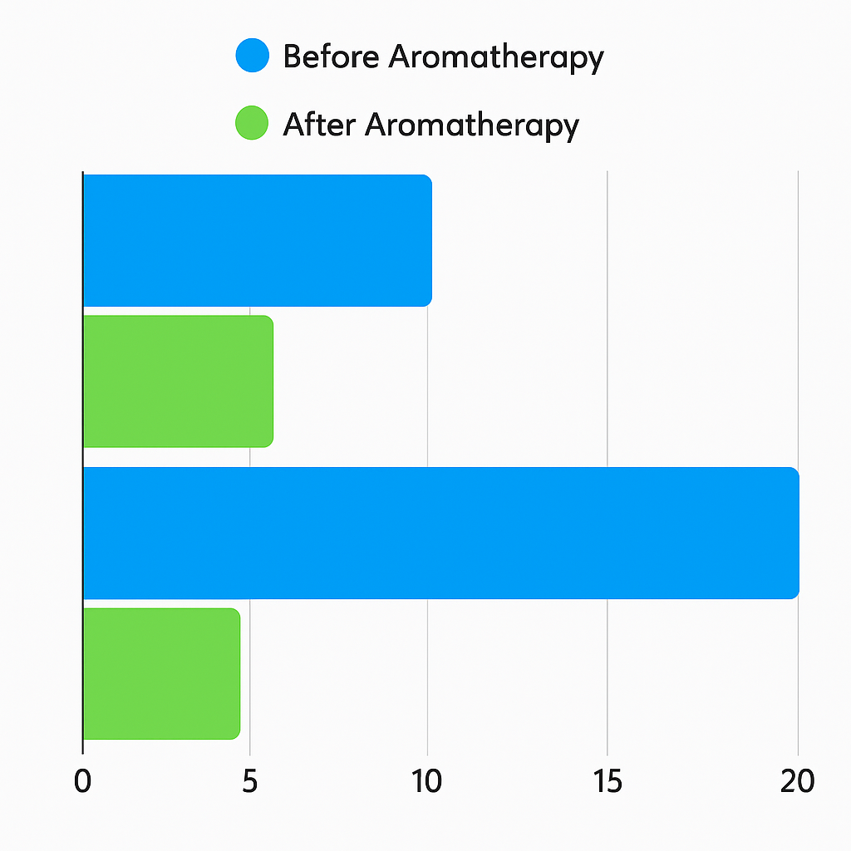
Figure 2: Comparative chart showing pre- and post-intervention levels of pain and anxiety.

Upon evaluating the acceptability across the study groups, therapeutic efficacy was found to be statistically consistent regardless of the method of essential oil administration—whether via a cream-based formulation, dilution in a neutral vegetable oil, or a combination of both.
All groups demonstrated a significant and consistent reduction in pathological anxiety symptoms, along with notable improvements in daily quality-of-life indicators. This symptom reduction exhibited a homogeneous pattern across all tested application modalities (Figure 3).

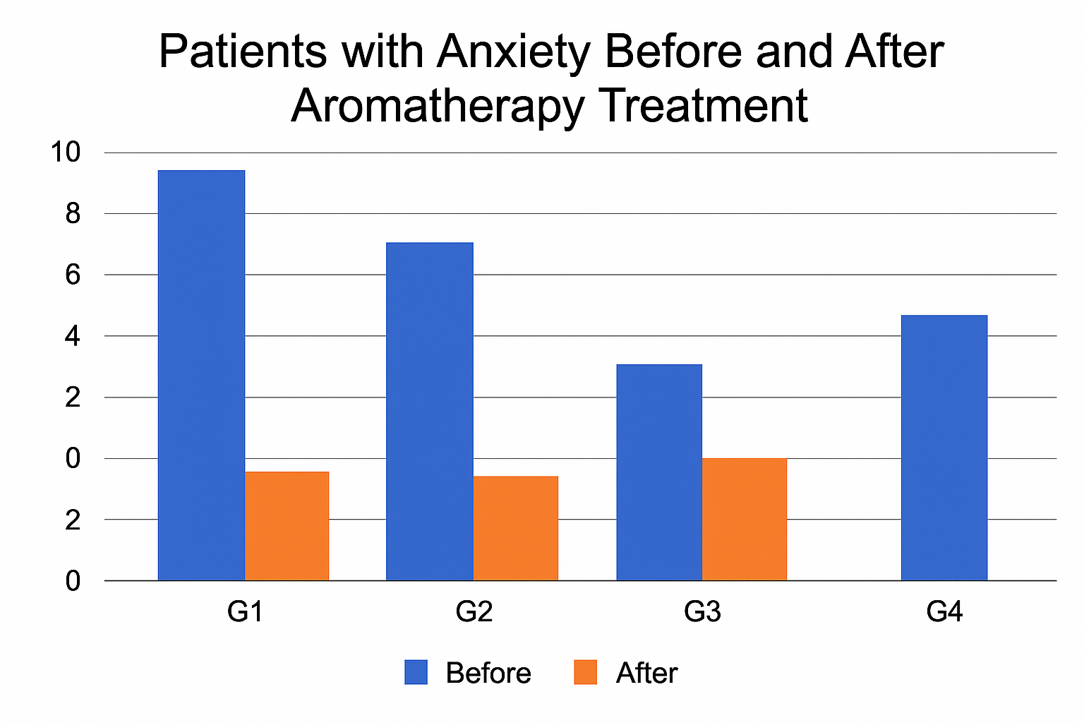
Figure 3: Comparison of the number of patients reporting anxiety before and after implementing the aromatherapy protocol.
- Conclusion
In conclusion, aromatherapy proves to be an effective therapeutic modality, acting holistically on both physiological and psychosomatic aspects of the human organism. Essential oil therapy stands out for its favorable pharmacological profile, characterized by a low incidence of adverse effects when compared to conventional synthetic agents.
Funding: None.
Research Ethics Committee Approval: None.
Acknowledgments: The authors would like to thank the Gaffrée and Guinle hospital for their support. Michelle C.P. Pereira thanks CNPq for the doctoral scholarship.
Conflicts of Interest: None.
Supplementary Materials: None.

References
- Buckle J. Clinical aromatherapy: essential oils in practice. 2nd ed. St. Louis: Churchill Livingstone; 2003.
- Tisserand R, Young R. Essential oil safety: a guide for health care professionals. 2nd ed. Edinburgh: Churchill Livingstone/Elsevier; 2014.
- Şentürk A, Kartin P. The effect of lavender oil application via inhalation pathway on hemodialysis patients’ anxiety level and sleep quality. Holist Nurs Pract. 2018;32(6): 1–7. doi:10.1097/HNP.0000000000000292. Available from: https://pubmed.ncbi.nlm.nih.gov/30320657/
- Keye G, Wasl M, Dietz A, et al. Aromatherapy in palliative care: a single-institute retrospective analysis evaluating the effect of lemon oil pads against nausea and vomiting in advanced cancer patients. Cancers (Basel). 2022;14(9):2131. doi:10.3390/cancers14092131. Available from: https://pubmed.ncbi.nlm.nih.gov/35565260/
- Gnatta JR, Zotelli MFM, Carmo DRB, Lopes CLBC, Rogenski NMB, Silva MJP. O uso da aromaterapia na melhora da autoestima. Rev Esc Enferm USP. 2011;45(5):1113–1120.
- Brito AMG, Rodrigues SA, Brito RG, Xavier-Filho L. Aromaterapia: da gênese à atualidade. Rev Bras Pl Med. 2013;15(4):789–793.
- Reis C, Barbosa LMLH, Pimentel VP. O desafio do envelhecimento populacional na perspectiva sistêmica da saúde. BNDES Setorial. 2016;(44):87–124. Available from: http://web.bndes.gov.br/bib/jspui/handle/1408/9955
- Faucon M. Aromaterapia e geriatria. Belo Horizonte: Laszlo; 2024
- Sacco PR, Ferreira GCGB, Silva ACC. Aromaterapia no auxílio do combate ao estresse: bem-estar e qualidade de vida. Rev Cient FHO UNIARARAS. 2015;3(1):1–8.
- Lyra CS, Nakai LS, Marques AP. Eficácia da aromaterapia na redução de níveis de estresse e ansiedade em alunos de graduação da área da saúde: estudo preliminar. Fisioter Pesqui. 2010;17(1):13–17.
- Silva SCSB, Medina ET, Oliveira TB, Valverde SS. A aplicação da aromaterapia como método de alívio da dor em gestantes: uma revisão integrativa. Vittalle Rev Cienc Saude. 2019;31(1):61–73.
- Eddin LB, Jha NK, Meeran MFN, Kesari KK, Beiram R, Ojha S. Neuroprotective potential of limonene and limonene-containing natural products. Molecules. 2021;26(15):4535. doi:10.3390/molecules26154535.

